Alliance School of Advanced Computing

Course Name: Graph Analytics
Course Code: E1ITC302
Assignment No: 1

Name of the Student: Mahi Kala

Registration Number: 2411021060486

A. Title of the Problem: Journey to the Moon

B. Problem Statement in Details:
The United Nations wants to send two astronauts to the Moon, and the two selected astronauts must be from different countries.
There are n astronauts, numbered from 0 to n-1. We are given pairs of astronaut IDs where each pair represents two astronauts who belong to the same country.
The task is to determine the total number of possible pairs of astronauts who belong to different countries.
Astronauts who are not mentioned in any pair are considered to belong to separate countries individually.
For example, if there are 5 astronauts and the same-country pairs are (0,1), (2,3), and (0,4), then:
- Astronauts 0, 1, 4 belong to one country.
- Astronauts 2, 3 belong to another country.
Therefore, the valid pairs are formed by choosing one astronaut from each country:
3 × 2 = 6
Hence, the answer is 6.

C. HackerRank/Leetcode Link of the Problem:
https://www.hackerrank.com/challenges/journey-to-the-moon/problem

D. Student’s Github Link of Report and Code Upload, along with the README File:
GitHub Repository: https://github.com/mahikala2312/Graph-Analytics

E. Solution Steps/Algorithm:
- Create a graph with n astronauts as vertices.
- For every given pair (a, b), add an edge between astronaut a and astronaut b.
- Astronauts connected directly or indirectly belong to the same country.
- Use Depth First Search (DFS) to find all connected components in the graph.
- Store the size of every connected component. Each component represents one country.
- Astronauts who do not have any connection form a country of size 1.

- To find valid pairs:
  - Choose astronauts from two different countries.
  - If the country sizes are a and b, the number of possible pairs is a × b.
- Add the products of all pairs of different countries.
- Return the total number of valid astronaut pairs.
Example:
For n = 5:
- Country 1 → {0,1,4} → size 3
- Country 2 → {2,3} → size 2
Number of valid pairs:
3 × 2 = 6
Therefore, the output is 6.

F. Code Developed:
def journeyToMoon(n, astronaut):
graph = [[] for _ in range(n)]

# Create the graph
for a, b in astronaut:
graph[a].append(b)
graph[b].append(a)

visited = [False] * n
country_sizes = []

# Find the size of each country
for i in range(n):
if not visited[i]:
count = 0
stack = [i]
visited[i] = True

while stack:
person = stack.pop()
count += 1

for next_person in graph[person]:
if not visited[next_person]:
visited[next_person] = True
stack.append(next_person)

country_sizes.append(count)

# Count pairs from different countries
answer = 0
previous = 0

for size in country_sizes:
answer += previous * size
previous += size

return answer

# Input
n, p = map(int, input().split())

astronaut = []

for i in range(p):
a, b = map(int, input().split())
astronaut.append([a, b])

print(journeyToMoon(n, astronaut))

G. HackerRank Test Case Passed Screenshot or Output Screenshot:

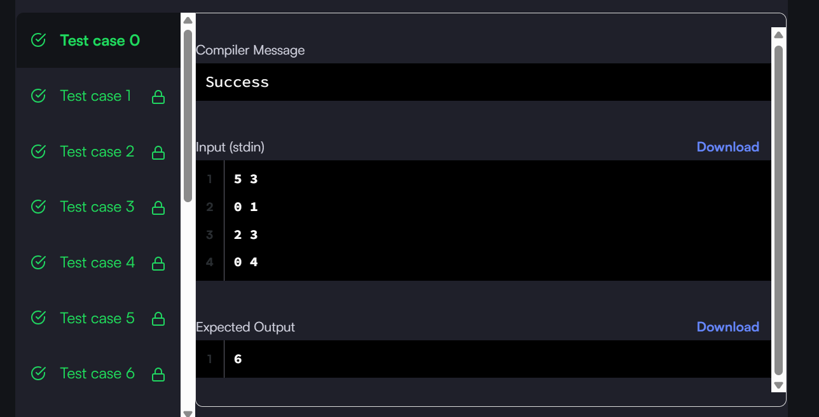

H. Observation:
The problem can be efficiently solved using Graph Traversal and Connected Components.
Astronauts belonging to the same country form a connected component in the graph. After finding the size of each country, the number of valid pairs can be calculated by multiplying the sizes of every two different countries.
The important observation is that we do not need to find every possible pair individually. Instead, we can calculate the number of pairs using the sizes of the connected components. This makes the solution much more efficient for a large number of astronauts.

